***Department of Computer Engineering***

***Course: CMPE281– Cloud Technology***

***Lab Assignment #2: Playing with Google App Engine***

Name: Navit Gaur

Instructor: Jerry Gao, Ph.D.

Semester: Fall 2015

Goal: This archive contains regulated exhibition of Google App Engine enlistment, design, improvement environment readiness (Eclipse), test venture creation (utilizing Google web toolbox) and sending procedures.

1. Sign in on Google App Engine with your Gmail credentials by going to appengine.google.com.

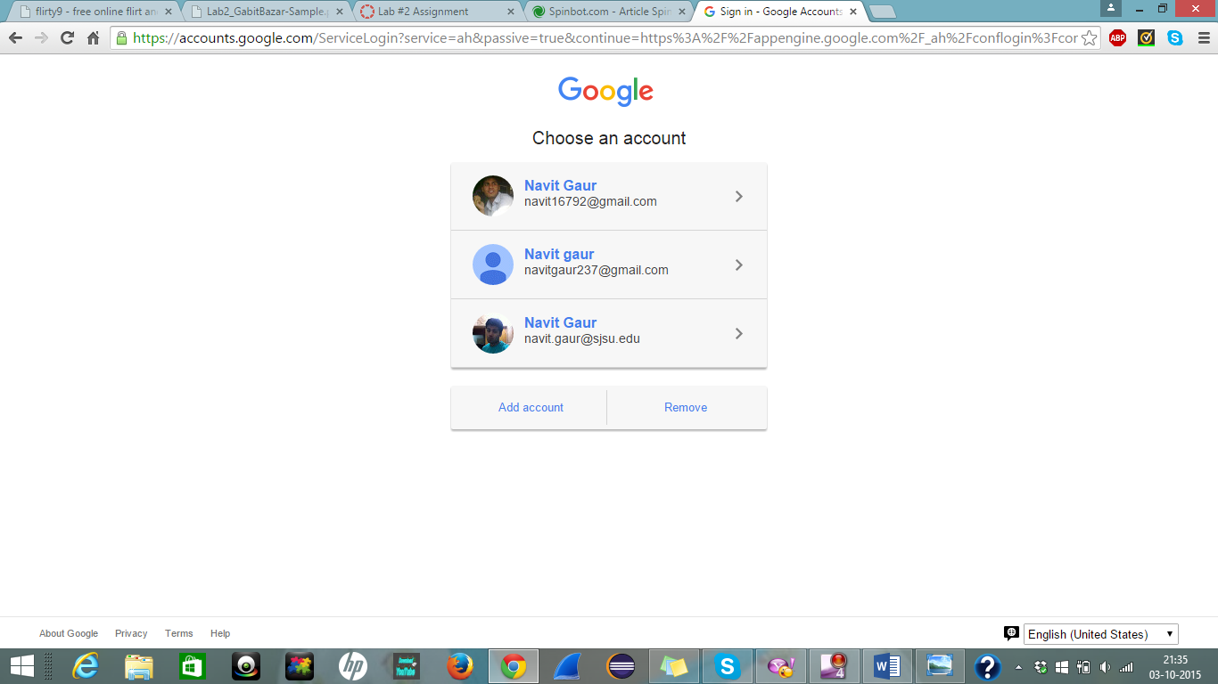

1. When you login with your credentials then on the welcome screen click on Create Application.

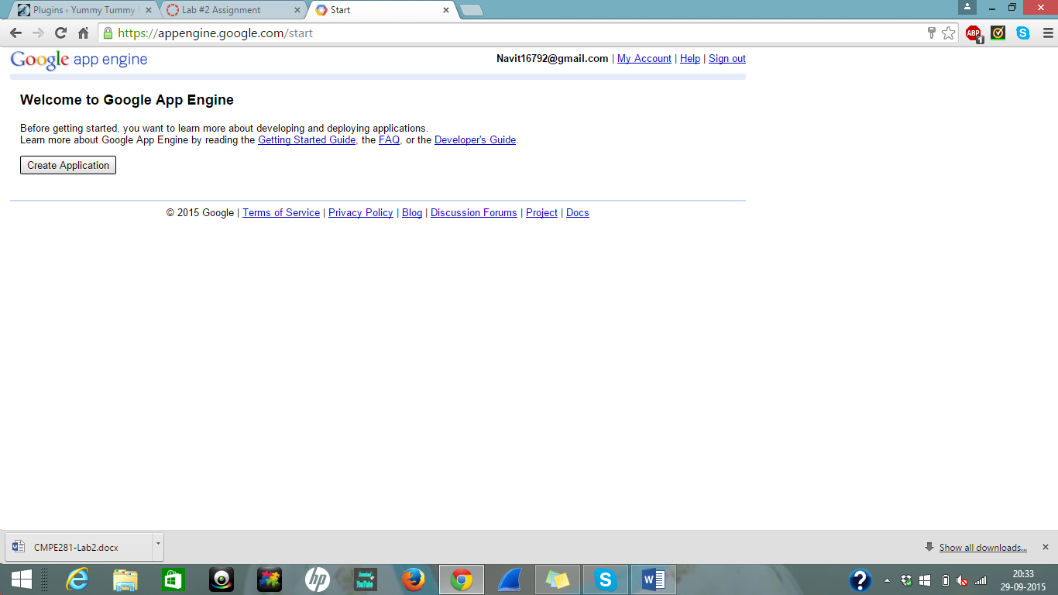

1. Now accept the terms and services and click on SUBMIT.

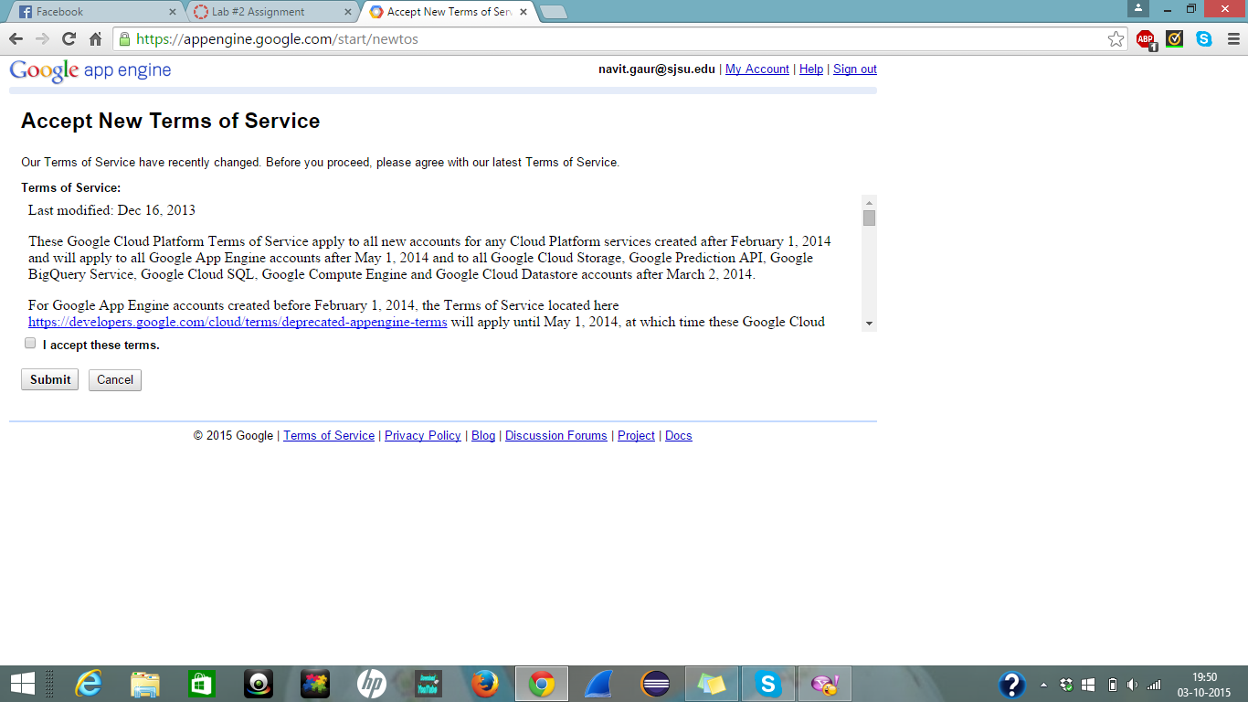

1. Select your Development console and click Create. If you see this screen then you are good to go.

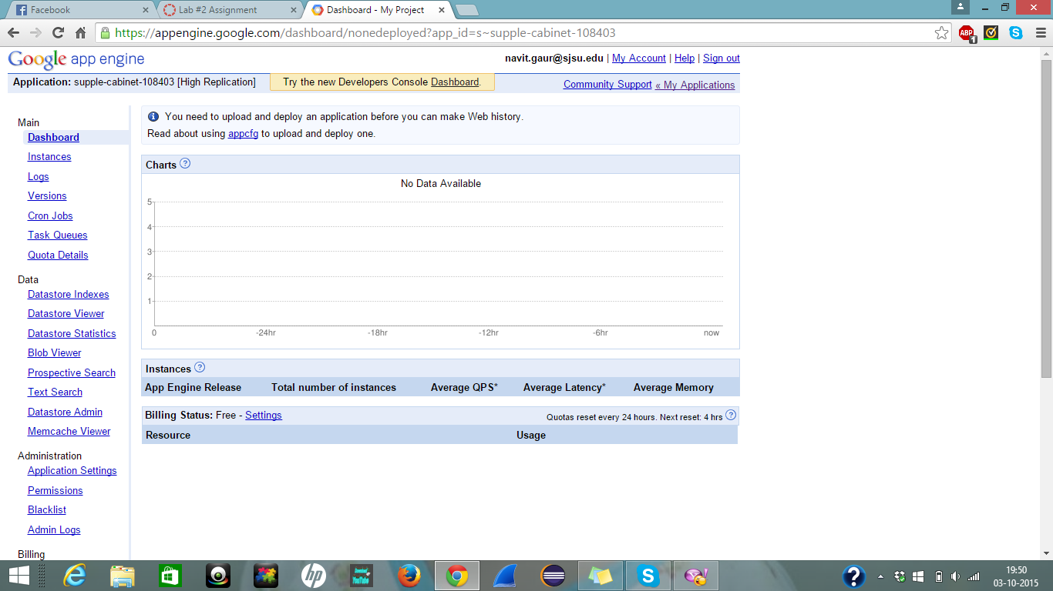

1. Now install ECLIPSE on to your system.

1. Go to Eclipse and under HELP click on ECLIPSE MARKETPLACE. Then in the search box type Google App Engine and click INSTALL.

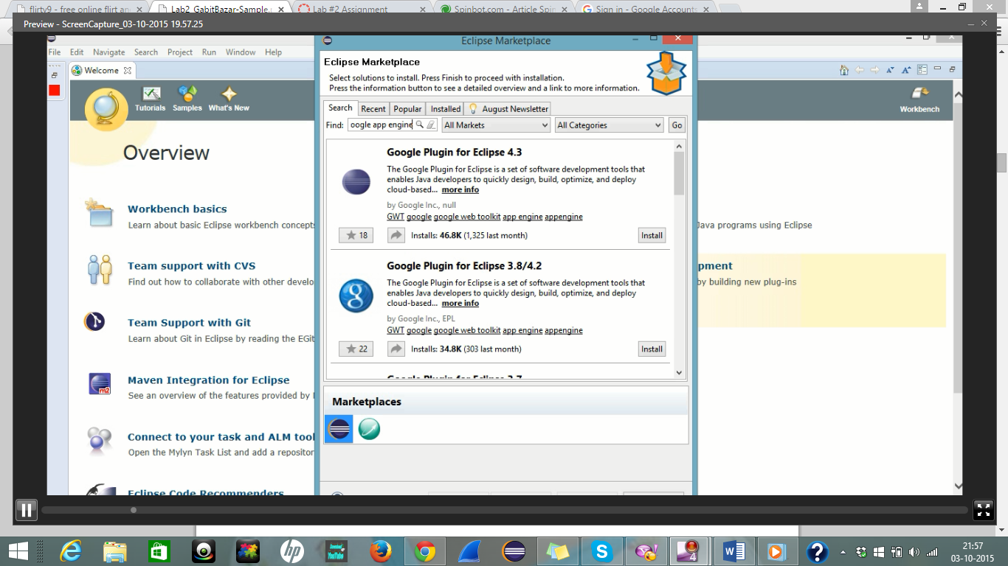

1. Accept the License Agreement.

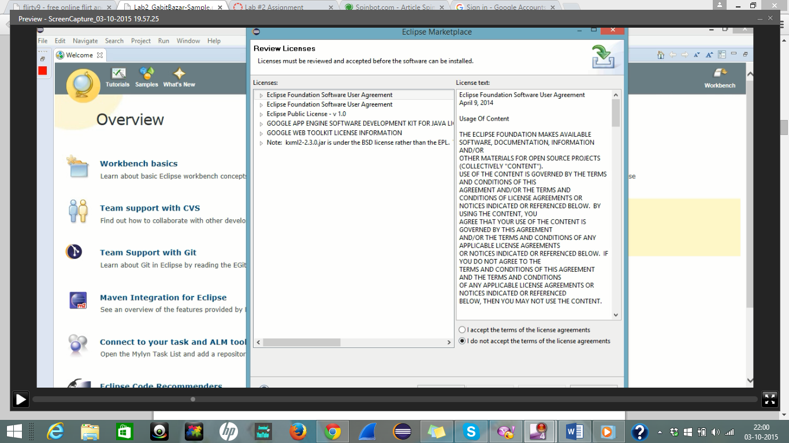

1. A dialog box with Installing Software appear.

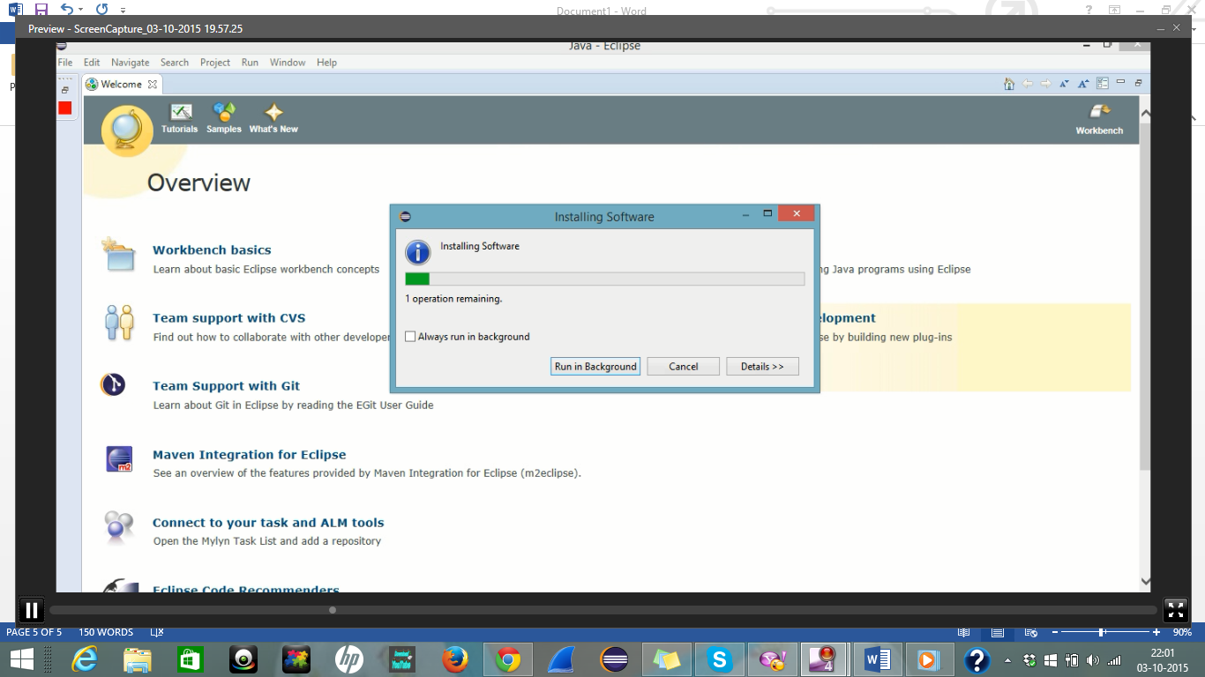

1. Once the installation is done Eclipse will restart after that you need to set location of SDK

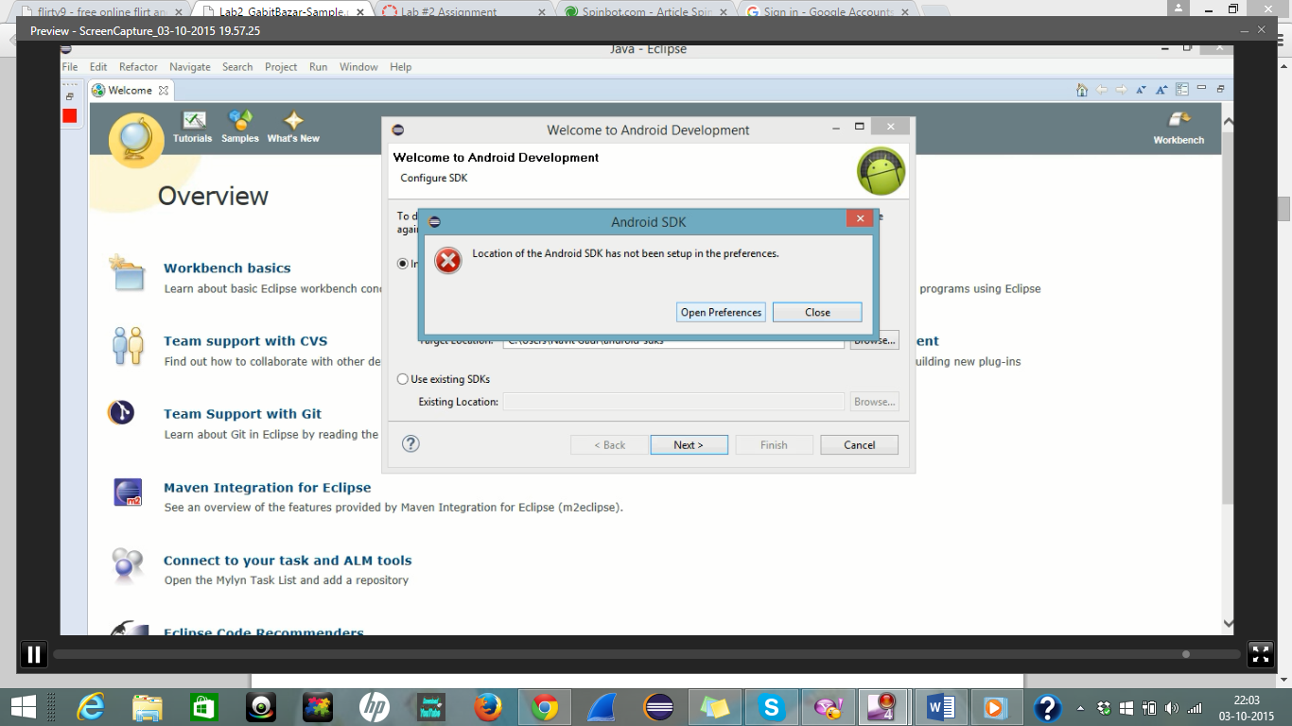

1. Install the SDK Manager.

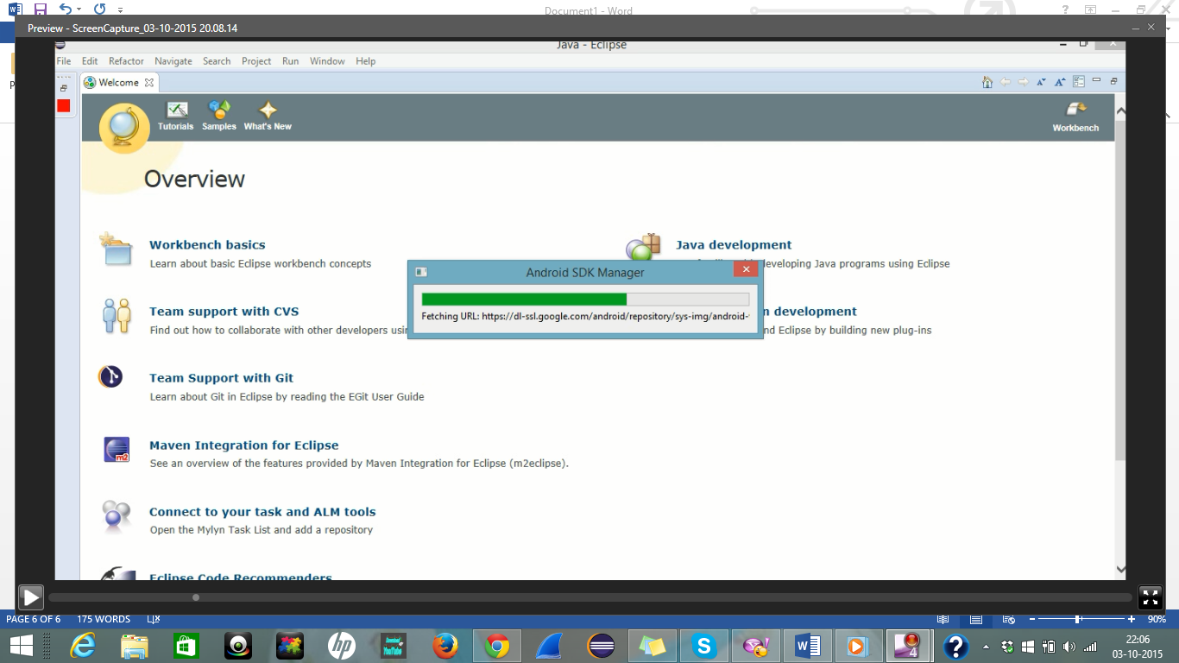

1. Make sure you install SDK Build-Tool package.

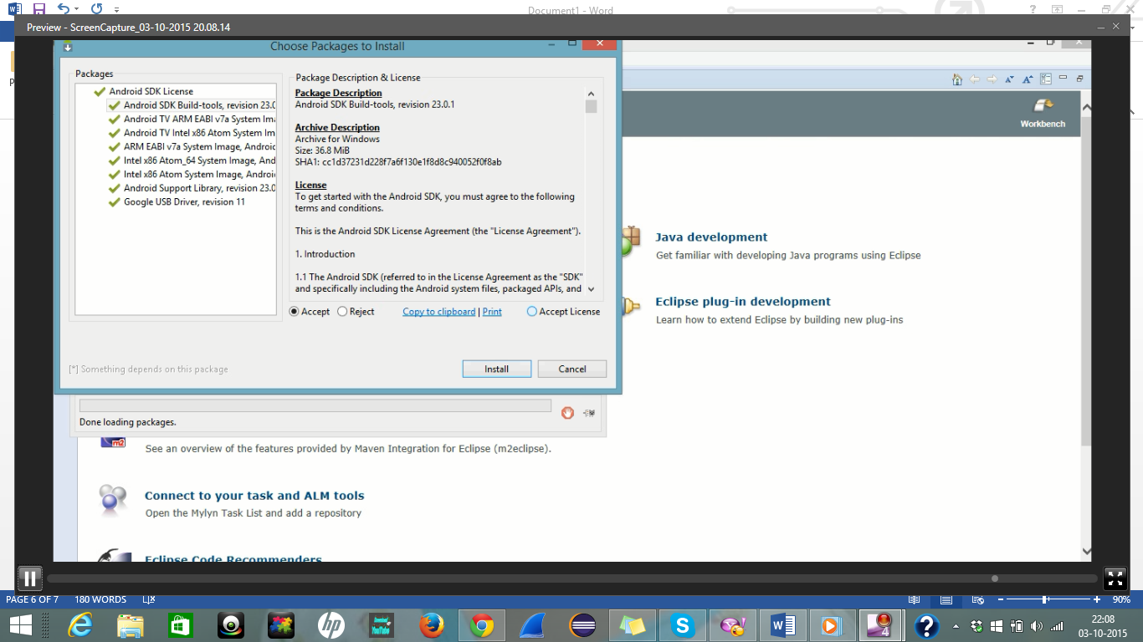

1. Once this is done you will see a small green Google icon at the top left corner.

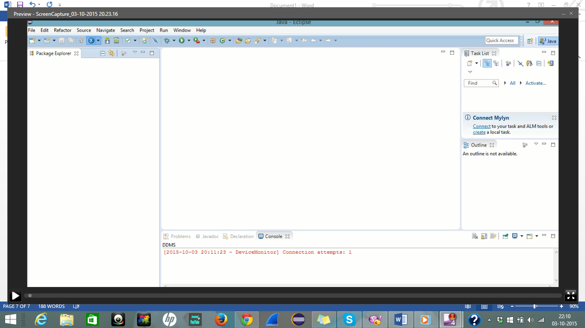

1. After this click on the drop down arrow near the google icon and click on Create Web Application Project. Then name the project and the package and click on CREATE. In my case I named project as navitgaur and package as navit.

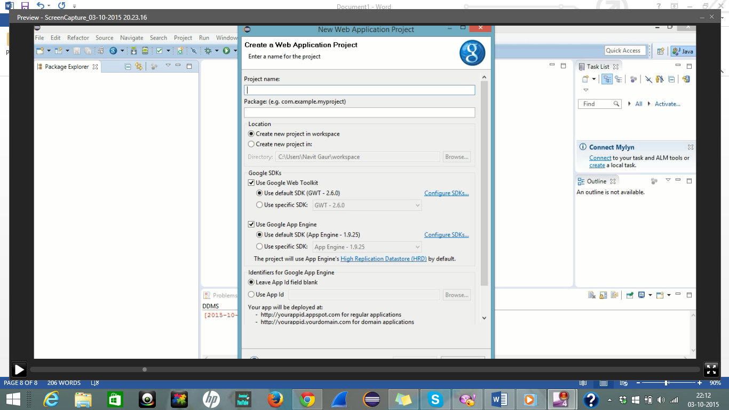

1. Under navitgaur project open appengine-web.xml file.

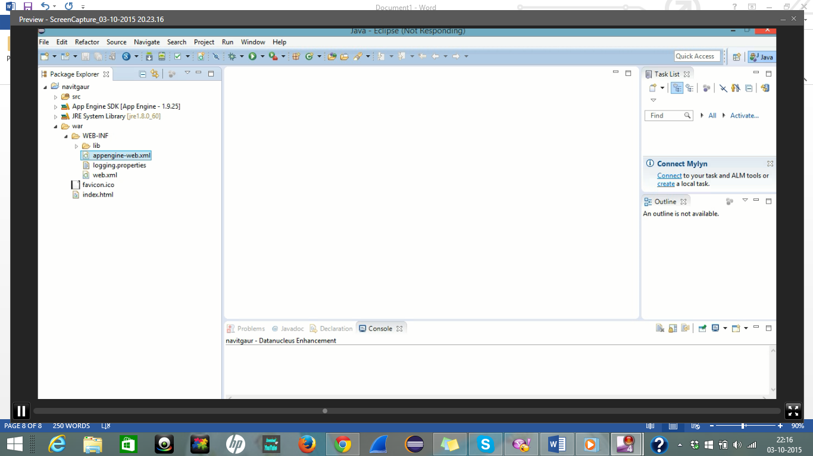

1. In the <application> tag enter the name of the application which you created in google app engine. In my case it is supple-cabinet-108403.

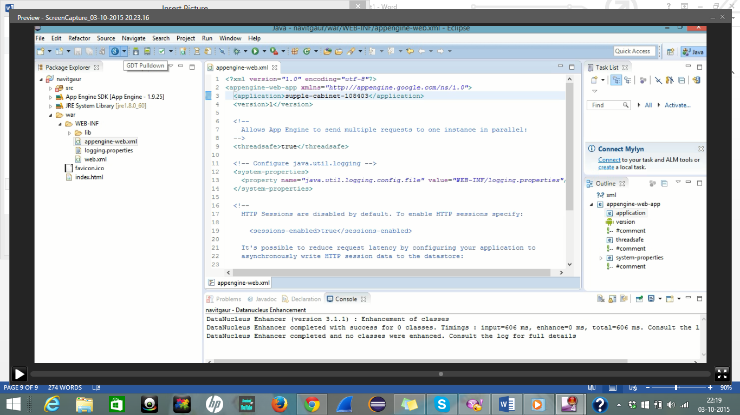

1. Then under same google icon click on deploy to app engine.

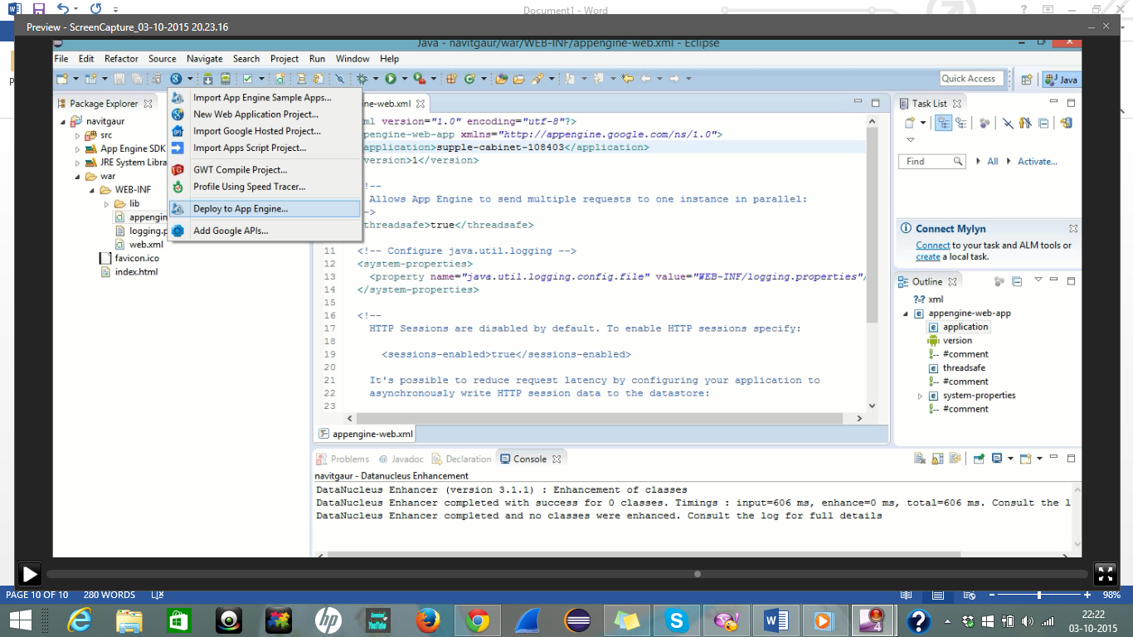

1. Again login with your credentials.

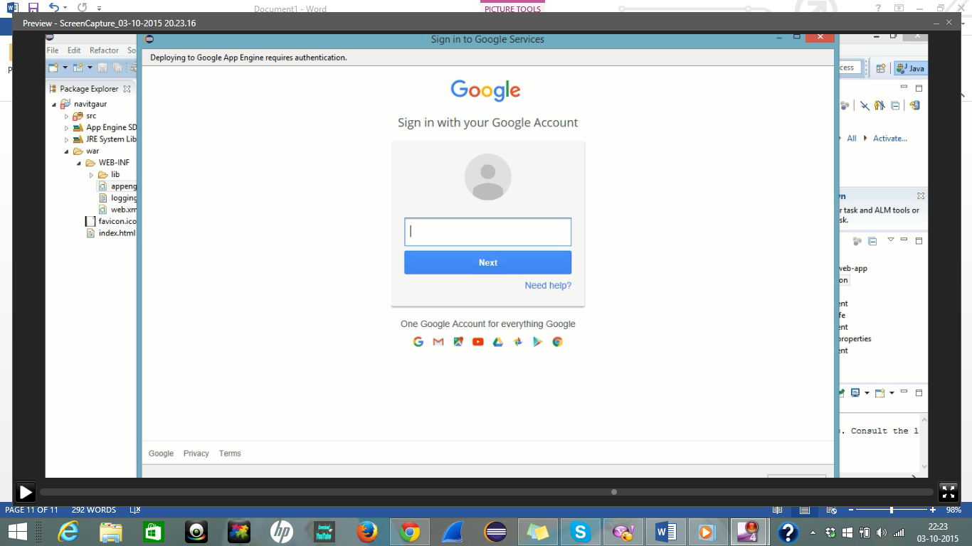

1. After this click on Deploy in the Deploy Project to Google App Engine.

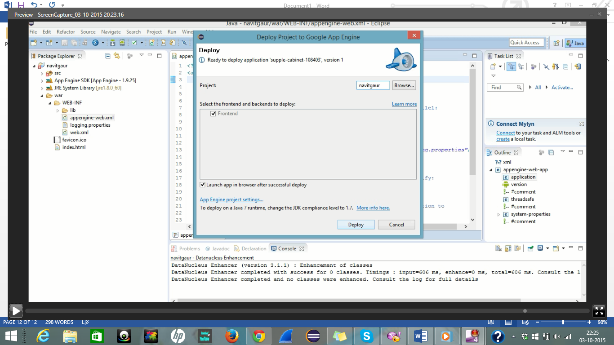

1. Once the deployment is done you will see the deployed application with your project name. In my case it is navitgaur.

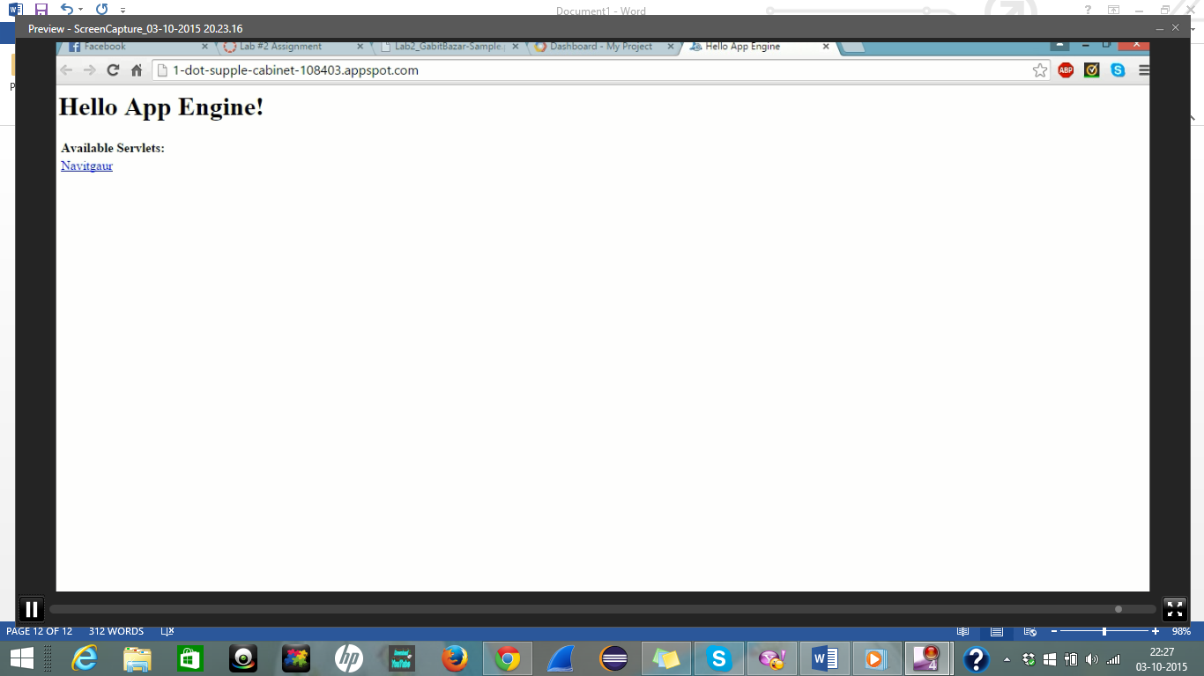

If you see this page then you are successful in your task.

Thank You

Navit Gaur

Student ID : 010702562